2) NAWURI
people name Nawuri
language Nawuri
home area Alfai about 250 sq km
main town Kpandai (population 1970 4,438; 1984 5,282; 2000 7,714)
other local peoples Bassari, Kotokoli, Konkomba [and who else?]
main town Kpandai
chief in 2008 Atorsah Bristiam Okore II
name of God Anenyeripe Ebware
principal local gods Nana Kosoe, Gyogo
main occupation farming
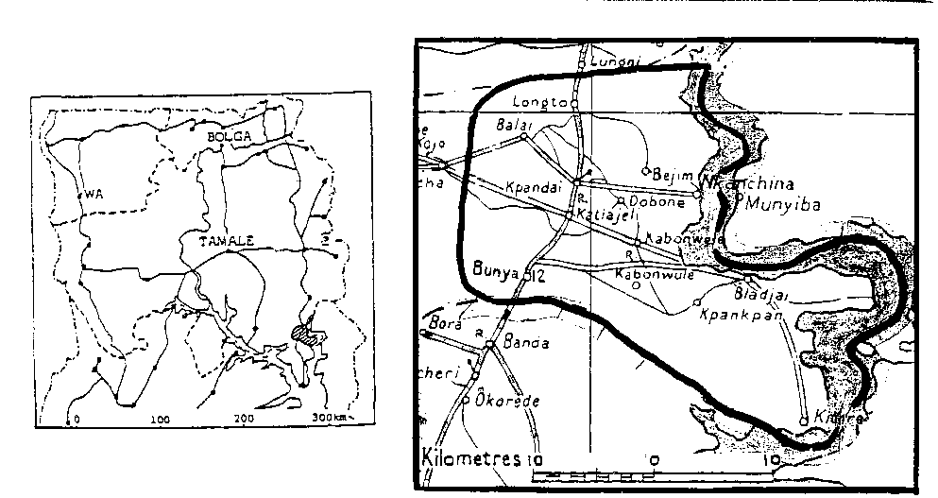
location a dozen villages around Kpandai, capital of Kpandai District; on the west bank of the Volta Lake/Oti River estuary, some 70 km north of Kete Krachi

NAWURI – A PERSONAL VIEW [who is to write this? could Fr Timothy Akanson do it? Let me know if he is willing to write a 400+ word essay on some aspect of Nawuri – life in a multi-tribal town, and its tensions and joys – your frustration at the failure of East Gonja District to provide a tarred road even for Kpandai town centre – your joy in the local Senior Secondary School and the range of subjects taught by talented teachers, and the number of bicycles parked daily, especially those belonging to girls, who in the past have been effectively denied any secondary education – or some other theme of your choice – if Fr Timothy does it he could write on any of the above subjects or perhaps of his challenges and experiences as a local priest]

NAWURI POPULATION
Table 1 NAWURI --COMPARISON BY YEAR
 | 1960 census | 1984 estimate | 2000 census | 2005 Ethnolog estimate | 2006 Joshua Project | 2010 independ’t estimate
3 N regions |  | 9,000
7 S regions |  | 900
 | not listed | 9,900 | not listed separately* | 14,000 | 15,330 | 18,000
*See table “Combined population of Akyode, Krachi, and Nawuri” in Krachi chapter page 2

LANGUAGE
Nawuri is a Kwa language of the Volta-Comoe (Guang) sub-group, closely related to Chumburung. No dialects are listed.
Language use Twi is used as a trade language, taught in school, and used in most churches.
LITERACY/BIBLE TRANSLATION
GILLBT started work | literacy work started | NT started | NT printed
1985 | 1984 | 1992
AUTHORITY AND CONFLICT
[all of this paragraph needs checking and correcting]
Traditional and local government Germany was the colonial power before World War 1, when the Nawuri were not subject to any other tribe, and had their own separate Alfai Local Council; however during the German period a Gonja trader named Jawula, a sickler who suffered from rheumatism, came to settle in Kpandai; he and his brother were gradually allowed to acquire an influential position in the town’s affairs. A Gonja chief popularly nicknamed Kununkuliwura legitimised Gonja control. When the British assumed control after World War I they found it convenient to treat Nawuri as subject first to Krachi, then to Gonja, and after Independence Ghana governments continued that arrangement, making Kpandai part of the East Gonja District with the Assembly at Salaga (a distance of 84 km); local people complained that proposed developments were not carried out, Nawuri assemblymen were not paid or given allowances, and the District failed to develop the town.
In 1966-69 the NLC made it part of a joint Kpembe-Kpandai Council, dominated by Gonja.
A struggle followed in the 1980s, resulting in violent conflict in 1991 (of which an account is given in Cletus Mbowura’s thesis). The bridge on the Salaga road was allowed to collapse and fall into disuse, but was rebuilt in
Since the creation of Kpandai District in 2008 [?] Nawuri is once again independent of outside control. There is a Nawuri paramount chief, under him there are "controllers of the land", and below them village chiefs.
There is a recognised line of succession to village chieftaincy but it cannot be determined rigidly and the final decision is made by the people, presided over by the priest of Nana Kosoe.
EDUCATION AND HEALTH
Education Kpandai SSS, founded in 1991, is the only SSS for the whole of the Nawuri area and beyond. Students come from as far as Kitare (30 km), Bladjai (20 km) Nkanchina and Kabonwule (12 km). The school has no hostel in Kpandai, so students either have to rent rooms in town or cycle in daily, coming in late after 1st and 2nd periods, and returning late to do their prep. The distance is too far for many girls to cycle, and some who lodged in town have become pregnant and returned to their parents; others have been forced to marry.
Health A Leprosarium was founded and run by the WEC Mission at Nkanchina, 12 km from Kpandai, from 1960 60 1978, when it was handed over to GHS as a health centre staffed by a medical assistant and a midwife; but it has no laboratory, no electricity, hence no way of doing tests although equipment stands there unused. Drugs are inadequate, and items like anti-snake-bite serum cannot be kept in a fridge. Purchase of fuel is a major item of annual expenditure.
There are government health posts with medical assistants at Kpandai, Kitare, and Bladjai, which refer cases to the hospital, and there are few TBAs in the villages.
Seriously ill patients including maternity cases short of blood have to travel 65 km to reach the nearest government hospital with better facilities, which is the East Gonja DSistrict Hospital in Salaga; or 50 km to the hospital at Bimbilla in Nanumba North District.
The Evangelical Church of Ghana (ECG) is currently constructing a private clinic with theatre facilities near Kpandai, and plans to engage a doctor.
Police Station Kpandai has a police station with a chief inspector who comes under Salaga District but the 8 personnel are inadequate and there is no vehicle to go to areas where there is trouble or to make arrests.
Transport All roads in the area are untarred, except for Kpandai town itself where the tarred surface was laid in unsuitable rainy conditions. Passenger lorries run through Kpandai from Volta Region to Northern Region. Local routes include: 1) Kpandai – Salaga; 2) Katiejeli – Bladjai; 3) Kpandai – Kabonwule – Kitare; 4) Kpandai - Kanchina [number and frequency?] The Metro bus service does not reach Kpandai, and local people feel that private vehicles charge too much.
Kanchina is (?) on the shore of the Volta Lake (River Oti estuary); boats call there, mostly private boats, sailing to local destinations.
Development A Bill to establish a Savannah Accelerated Development Authority is passing through Parliament in 2010-2011, and should result in new structures and new funds for development of the whole of northern Ghana in the coming years.
RELIGION
estimated %age | Traditional | Muslim | Christian | No religion
1986 | 80 | 17 | under 1
2006
Traditional Religion
Anenyeripe Ebware or Ibware is the supreme God; the title means "almighty". [What name does the Nawuri Bible translation use for God?]
When libation is poured to the ancestors, and in all sacrifices and rituals, Ibware is mentioned first; he is given priority. It is only in sacrifices to Kankye, the earth shrine god of Balai, that the supreme God is not mentioned.
Ibware is feared, and receives worship and prayer. He created and controls all things. The earth gods, other gods, and all spiritual powers come from him and are his agents.
Nawuri believe that God is above, he sees everything and knows everything. So in times of sorrow and suffering the words of consolation are “Give it to God, for he knows everything and can do everything”.
“We cannot see God with our eyes but he is real. We come from him and we shall return to him. We therefore love and respect God, and hold him in high esteem. The last cry for help is to God, because we know he cannot fail us.”
(JD)
Earth shrines Each town and village has its own earth shrine, served by a priest who is usually the oldest person in the community. Its major function is protection of the community from impending disaster, witches, sickness, etc. It also provides the community’s needs: peace, children, good harvest, success in business.
The new guinea corn festival is celebrated annually at each shrine. People visit these shrines in times of need and to make special requests, and they promise to pay something — a sheep, goat, dog, or money — if they are successful. Names and locations of Nawuri earth shrines are listed below:
LISTS OF CLANS AND GODS, given by John Daborney: these lists have numerous gaps and will be of little use until they are completed and we have a full explanation of the roles of clans, shrines, and gods. Mere lists of names do not mean much.

NAWURI TOWNS AND EARTH SHRINES
Town | Clan | Name of shrine/god | Functions &c
Kpandai |  | Nnogyulo
 |  | Nana Oyoru
Kpandai |  | Gyogo Challans *
Balai |  | Kankpe
Balai |  | Nana Osuwuli?
Nkanchina |  | Nana Osuwuli
Kitare |  | Nana Okpandati
Kabonwale |  | Nana Buyia  Protector
Bladjai |  | Nana Bwala  Land-Owner
Nyare |  | Nana Buyu Kyikyiri
Katiejeli
Dodo-Ayi
* Priesthood of Gyogo It is said that the oldest person in the clan is installed as priest of Gyogo through a three months’ initiation course involving the “Challans” of Challa, Odome, near Nkwanta; initiates are chosen by sacrificing a fowl – if a person is to be initiated the slaughtered fowl will lie flat on its back. However it is not clear whether this relationship between the Nawuri of Kpandai and the Challa of Odomi is legend or fact. Odome is about 70 km directly east of Kpandai, beyond the Oti River estuary of the Lake (there is no direct route to Odome and no major ferry nearer than Dumbai), and it is said that the last priest was installed in 1990. [We need recent information on the Kpandai-Odomi relationship and what it involves in practice.]
gods In addition to the earth shrine of a town, clans in every community have numerous gods, listed below with location.
OTHER GODS
Town | Clan | Name of god | Functions &c
KPANDAI | Aborakyina | Nana Nyuntilo | new guinea corn festival
 | Kasi | Nana Kulenkpa
 | Agyande | Tembesu | earth god (“fetish”)
 | Nnogyilo
BALAI |  | Kankpe
 |  | Nana Osuwili | earth shrine
NKANCHINA | Akabite | Kpalumpu
 | Dengtensu | Nana Osuwili
 | Linkpa | Tigari
 | Kyirai | Kyiko
 | Barich
 | Sinkpa-ayi
 | Laji
KITARE |  | Okpandanti | major god
 |  | Nana Lii | river god
 | Imanuane/Bonkpan | Nana Gle
 | Odamansu | Nana Kepini | protection, provider
KABONWULE |  | Nana Buyia
 |  | Nana Oman
 |  | Nana Bunkpan
BLAJAI |  | Nana Bawla | main god: bees: helps in war
 |  | Nana Aka | in a cave, in part a shelter for slave raiders
 | Doti | Nana Kpabiri
 | Ankiamo | Prepren Kewaraja | stool for installation of chiefs

An odakpa or guardian spirit may be a tree or river, or a stone or moulded object bought from a shrine for personal protection. These gods are personal and private. Some are for protection, economic advancement, and healing. Others are for destruction. Those who have the destructive type are said sometimes to die as witches or wizards, and cannot be reincarnated.
Taboos Taboos are common but they differ from town to town or clan to clan. gods have their own taboos.
The Kabeso clan of Balai don’t eat rabbit.
Njare people taboo a partridge.
Nawuri do not eat python in Kpandai.
Planting of millet is taboo in Nawuri land.
Kpandai and Balai don’t offer sacrifices to their gods on Wulensi or Yendi market days.
Diviners Gyogo* and Kankpe* are also diviners, through slaughtering fowls. They find out thieves, witches, and adulterous men and women. [*does this mean the priests of Gyogo and Kankpe?]
Ancestors, sacrifices, and libations Nawuri invoke ancestors by offering sacrifices of fowls, drink, and animals, and pouring libation. Libation involves calling on the name of God and asking him to come to receive water and answer their sacrifice. The roll of ancestors follows, the oldest mentioned first, then the others in order of seniority up to the head of clan who died most recently. Then water is poured. If the sacrifice is to a god, the name of the god is mentioned before the fowl is slaughtered. Special requests may be made for health, protection, or in times of danger.
Only good ancestors are invoked and sacrificed to. Bad ancestors are those who died as witches, wizards, or with bloated stomach.
Women’s gods Igyiolija is a women’s goddess. Her odakpa or digi are Chankpana and Ɔlichɛ. They come for nine days during which the women [which women?] go round with sticks, dancing (digi), and drumming. The last initiation was in 1980.
Witches are thought to travel from one village to a different one every 9 days. Witch-finders can see them only at night; for this purpose they wear cowrie-shells on their arms, and ear-rings.
In sickness it is usual to go to a soothsayer to find out whether one has offended an ancestor. If so the soothsayer will identify the ancestor concerned and prescribe the necessary sacrifices, which are performed on the ancestor's grave.
Islam
There were very few Muslims in the Nawuri area. [what is the position now? do the Kotokoli have a mosque in Kpandai? are there Muslims from other peoples?]
Christianity
Christianity was first introduced in 1944 by the WEC Mission and now several denominations work in the area. In 10 localities the various churches have the following:

 | AOG | Cath | COC | COP | DL | ECG | EP | Global | SDA
congregations 1986  2010 | 1 | 7  7 | 1 | 5  5 | 1 | 9  9 | 1  1 | 1 | 1
church buildings 1986  2010 |  | 4  4 |  | 1  1 |  | 4  4
pastors/priests 1986  2010 |  | 2  2 |  | 1 |  | 8
members claimed 1986  2010 |  | 250? |  | 180 |  | 357
church attendance 1986  2010 |  |  |  | 160 |  | 438

PUBLISHED OR UNPUBLISHED DOCUMENTS
Cletus Mbowura Thesis on Nawuri-Gonja conflict (History Department, Legon)
Report of Gonja-Nawuri Conflict Commission following events of 1991 (Nana Torsah, La Bone, Accra, has a copy)
CONTRIBUTORS
Rod Casali, questionnaire answers, GEC, 1985 (RC)
John Kofi Daborney (JD)
Samual Ntiamoah (SN – Ngyinnine)
John Asuo (JA)
CONTACTS
Fr Timothy Akanson, Catholic Church, Kpandai 0244 109673
Joseph Kojo Atorsah, Revenue Dept, Kpandai
Dr Cletus Mbowura, History Dept 0277 764612

